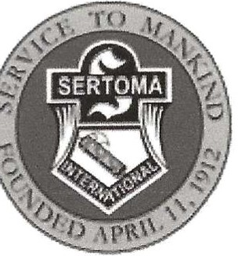Tun/Bamberger Scholarship Fund

Administered by the Sparks Sertoma Club Founded by the Northern Nevada Sertoma Club Soarks Sertoma Club is a 501(c)3 Oroanization

We are pleased to make available the sum of $2,000.00 to be used toward tuition, books or other educational costs at any accredited NEVADA college. Scholarship money will be place with the Financial Officer of your chosen college. If you are chosen for a scholarship, you will be requested to attend a meeting of the Sparks Sertoma Club to receive your Scholarship Certificate. Please fill out the following application and submit your application by mail to:

Sparks Sertoma Club

P.O. Box 538

Sparks, Nevada 89431

Applications must be postmarked by: April 15, 2025. Applications postmarked after that date will not be accepted.

Name: Age: _ Address: _City: _ Zip: Phone: ( )_-

Last Washoe County High School attended or currently attending: _

G.P.A. (four (4) years) You must attach a copy of current High School Transcript. Have you attended a High School in Washoe County all four years? _

The career you plan to pursue in college and the college you plan on attending: (Use separate sheet if needed.)

Community Service: (Work done in the community to help your fellow citizens). Explain why you should be selected to receive this scholarship. (Use separate sheet if needed.)

Name, Address and Telephone number of at least three references. (I.e. teacher, principal, employer)

1.

2.

3.